Fraction Models

Journal Prompt

Description: BD05629_

Write an addition or subtraction word problem that uses mixed numbers. Then, solve the problem using a visual model and an equation.

|  |
| --- |
|  |
|  |
|  |
|  |
|  |
|  |
|  |
|  |
|  |
|  |
|  |
|  |

Hundredths Circles Homework

Directions:

1. Complete Equation 1. Shade in the appropriate amount on the hundredths circle.
2. Create two other equations that would have sum that is equivalent to Equation 1. The addends in your equations must include both tenths and hundredths.

**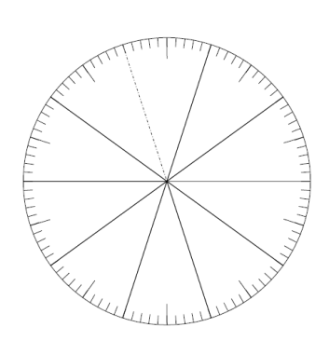**

**Equation 1: 6/100 + 6/10**

**Equation 2: \_\_\_\_\_\_\_\_\_\_\_\_\_\_\_\_\_\_\_\_**

**Equation 3: \_\_\_\_\_\_\_\_\_\_\_\_\_\_\_\_\_\_\_\_\_**

**Equation 1: 2/10 + 76/10 0**

**Equation 2: \_\_\_\_\_\_\_\_\_\_\_\_\_\_\_\_\_\_\_\_**

**Equation 3: \_\_\_\_\_\_\_\_\_\_\_\_\_\_\_\_\_\_\_\_\_**

**B.**

**A.**