Name:_____________________Date:_______________
Perplexing Problems (HW)

1. The area of a large hallway is 24 square meters. The width of the hallway is 2 meters.
What is the length of the hallway?

2. A plan for a house includes rectangular room with an area of 60 square meters and a perimeter of 32 meters.
What are the length and the width of the room?

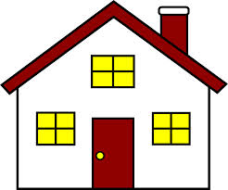

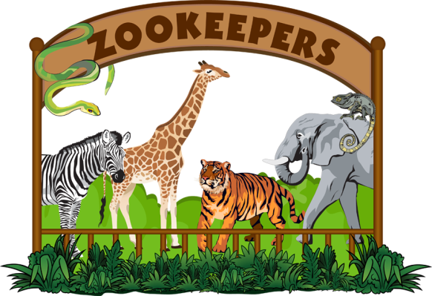
Animal Enclosures at the Zoo
Directions: Solve below using an equation. Remember to label solutions using the correct units. After solving, choose which animal at the zoo this enclosure might belong.
1. Given the area of each animal enclosure below, find the unknown side length.
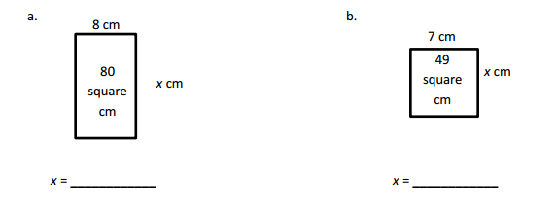
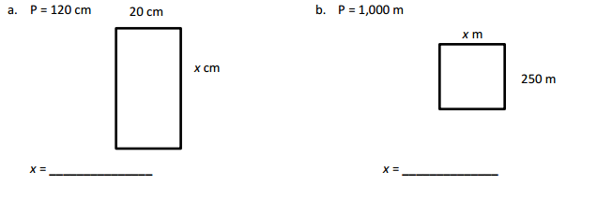
2. Given the perimeter of each animal enclosure below, find the unknown side length.
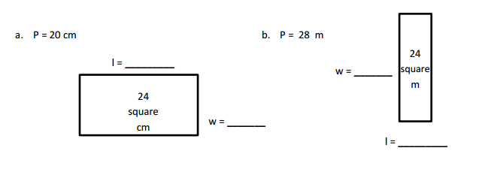
3. Each of the animal exhibits below is represented in whole number side lengths. Given the area and perimeter, find the length and width.

Playground at the Park-HW
The community park is adding new play areas and equipment on the playground. The plan below shows part of the new park.

- The new playground space has a length of 8 yards.
- The new playground space has an area of 48 square yards.
- Attached to the playground is a sandbox.
  - The width of the sandbox is half the width of the playground.
  - The sandbox is a square.

Can you find the area of just the sandbox? Use the space below to show the steps and explain your answer using precise language, symbols and numbers.

